MARKETPLACE API

An Industry Oriented Project Report Submitted
In partial fulfillment of the requirements for the award of the degree of

Bachelor of Technology
in

Computer Science and Engineering

by

SAI SUSRITHA RAVIPUDI 22N31A05K7

NAVYA SRI POCHAMMALA 22N31A05H7

SAI VAMSHI RAYAKANTI 22N31A05K8

Under the esteemed guidance of
Ms Agnisha Mandava
Assitant Professor



Department of Computer Science and Engineering
Malla Reddy College of Engineering & Technology
(Autonomous Institution- UGC, Govt. of India)
(Affiliated to JNTUH, Hyderabad, Approved by AICTE, NBA &NAAC with ‘A’Grade)
Maisammaguda, Kompally, Dhulapally, Secunderabad – 500100
website: www.mrcet.ac.in
Malla Reddy College of Engineering & Technology
(Autonomous Institution- UGC, Govt. of India)
(Affiliated to JNTUH, Hyderabad, Approved by AICTE, NBA &NAAC with ‘A’ Grade)
Maisammaguda, Kompally, Dhulapally, Secunderabad – 500100
website: www.mrcet.ac.in

CERTIFICATE

This is to certify that this is the bonafide record of the project entitled “project title”, submitted by SAI SUSRITHA RAVIPUDI (22N31A05K7),NAVYA SRI POCHAMMALA (22N31A05H7) and SAI VAMSHI RAYAKANTI (22N31A05K8) of B.Tech in the partial fulfillment of the requirements for the degree of Bachelor of Technology in Computer Science & Engineering, Department of CSE during the year 2023-2024.

Internal Guide Head of the Department
Ms Agnisha Mandava Dr. S.Shanthi
Assistant Professor Professor

External Examiner

ABSTRACT

The Marketplace API project revolutionizes how businesses harness data from major online stores to drive informed decisions in today's dynamic e-commerce landscape. With simplicity and effectiveness at its core, our platform empowers businesses of all sizes to understand market trends, customer behavior, and competitor activity. By leveraging these insights, businesses can optimize strategies, refine product offerings, and gain a competitive edge in the online marketplace.

Our API is designed for accessibility, catering to both novices and experienced developers. With user-friendly documentation and robust support resources, businesses can seamlessly integrate essential sales data and implement advanced analytics. From tracking product trends to monitoring competitor strategies, our platform equips businesses with the tools they need to thrive amidst the rapid evolution of online shopping.

Our commitment is to empower businesses to succeed in the digital marketplace. With the Marketplace API project, you gain access to unparalleled insights, enabling you to make informed decisions and stay ahead of the competition. Join us and unlock the full potential of your business in the dynamic world of e-commerce.

TABLE OF CONTENTS

S.NO | TITLE | PG.NO
1 | INTRODUCTION  1.1 DEFINITION AND SCOPE OF THE PROJECT  1.2 EXISTING AND PROPOSED SYSTEM | 01  01  03
2 | SYSTEM ANALYSIS  2.1 HARDWARE AND SOFTWARE REQUIREMENTS | 4
3  4  5 | SYSTEM DESIGN  3.1 UML DIAGRAMS  IMPLEMENTATION  4.1 SAMPLE CODE  4.2 OUTPUT SCREENS  CONCLUSION | 5  5  10  11  25
 | BIBLIOGRAPHY | 30
- INTRODUCTION

1.1 DEFINITION AND SCOPE OF THE PROJECT

The Marketplace API project introduces a cutting-edge platform designed to transform how businesses leverage data from prominent online marketplaces to drive informed decisions and gain a competitive advantage in today's dynamic e-commerce environment. In the digital age, access to accurate and comprehensive market insights is paramount for businesses striving to thrive in the fiercely competitive online marketplace. The Marketplace API project addresses this need by providing a robust and user-friendly interface for accessing essential sales data, monitoring market trends, analyzing customer behavior, and tracking competitor activity across various online platforms.

Key Features:

- Data Accessibility: The Marketplace API offers businesses seamless access to a wealth of sales data from leading online stores, enabling them to gain valuable insights into their performance and market dynamics.

- Comprehensive Analytics: With advanced analytics capabilities, businesses can delve deep into sales metrics, customer demographics, product trends, and competitor strategies to inform strategic decision-making and optimize their e-commerce strategies.

- User-Friendly Documentation: The API comes with comprehensive and easy-to-understand documentation, catering to both novice and experienced developers. This ensures smooth integration and maximizes the utility of the platform for businesses of all sizes.

- Scalability and Flexibility: Designed with scalability and flexibility in mind, the Marketplace API accommodates businesses of varying scales and adapts to evolving market conditions, empowering them to stay ahead of the curve in the ever-changing e-commerce landscape.

- Security and Reliability: Security is paramount in handling sensitive sales data. The Marketplace API prioritizes data security and reliability, implementing robust authentication mechanisms and ensuring data integrity to safeguard businesses' valuable information. The scope of the Marketplace API project encompasses the development and implementation of a comprehensive platform that enables businesses to access, analyze, and utilize essential sales data from major online marketplaces. The project includes the following key components and functionalities:

- Data Integration: Integration with leading online marketplaces such as Amazon, eBay, Shopify, and others to retrieve sales data, product information, and customer details.

- Data Retrieval and Storage: Development of robust data retrieval mechanisms to fetch sales data, including order details, transaction history, product listings, and pricing information, from the integrated marketplaces. Storage and organization of retrieved data in a centralized database or data warehouse for efficient management and analysis.

- Analytics and Insights: Implementation of advanced analytics algorithms and tools to analyze sales data, identify market trends, track customer behavior, and evaluate competitor activity. Generation of comprehensive reports, dashboards, and visualizations to present key insights and performance metrics, facilitating informed decision-making by businesses.

- API Development: Design and development of a user-friendly API interface that allows businesses to interact with the platform programmatically, enabling seamless data retrieval and integration into existing workflows and applications. Documentation of API endpoints, parameters, and usage guidelines to assist developers in integrating the Marketplace API into their applications effectively.

- Scalability and Performance: Implementation of scalable and resilient infrastructure to handle large volumes of data and accommodate growing user demand over time. Optimization of data processing pipelines and query performance to ensure timely retrieval and analysis of sales data, even during peak usage periods.

- Security and Compliance: Implementation of robust security measures to protect sensitive sales data and user credentials against unauthorized access, data breaches, and cyber threats. Compliance with industry regulations and standards governing data privacy, such as GDPR, HIPAA, and PCI-DSS, to ensure the secure handling and storage of customer information.

1.2 EXISTING AND PROPOSED SYSTEM

In the absence of the Marketplace API project, businesses rely on manual methods or disparate tools to gather, analyze, and interpret sales data from various online marketplaces. The existing system typically involves the following processes:

- Manual Data Collection: Businesses manually gather sales data from online marketplaces, often through web scraping or manual exporting.
- Data Fragmentation: Collected data is stored across disparate platforms or spreadsheets, making consolidation and analysis difficult.
- Limited Analytics: Lack of advanced analytics tools leads to suboptimal decision-making and missed growth opportunities.
- Time-Consuming Analysis: Manual processing and analysis require significant time and resources, leading to inefficiencies.
- Security Risks: Handling data manually poses security risks like breaches and compliance issues, compromising customer information.

The Marketplace API project introduces a revolutionary platform that transforms the way businesses access, analyze, and leverage sales data from major online marketplaces. The proposed system offers a range of innovative features and functionalities to streamline data management, enhance analytics capabilities, and empower businesses to make informed decisions:

- Automated Data Retrieval: The Marketplace API automates data retrieval, ensuring accuracy and completeness.
- Centralized Data Repository: Sales data is stored centrally, facilitating unified analysis and reporting.
- Advanced Analytics Tools: Businesses can utilize advanced analytics to derive actionable insights and optimize strategies.
- Real-Time Reporting: Generate real-time reports and dashboards for proactive decision-making.
- Secure Data Handling: Prioritize data security and compliance with robust encryption and access controls.
- Scalable Infrastructure: Scalable infrastructure ensures performance and reliability as user demand grows.
- Developer-Friendly API: Easy integration with existing workflows via user-friendly API and comprehensive documentation.

2. SYSTEM ANALYSIS

2.1 SOFTWARE AND HARDWARE REQUIREMENTS

Software Requirements:

- Operating System Compatibility: Ensure compatibility with Windows, macOS, and Linux.
- Database Management System (DBMS): MySQL, PostgreSQL, or MongoDB for efficient data management.
- Programming Languages and Frameworks: Python/Flask or Java/Spring Boot for backend, React or Angular for frontend.
- Web Server: Apache or Nginx for hosting and handling HTTP requests.
- Security Tools and Libraries: OAuth 2.0 for authentication, SSL/TLS for encryption, JWT for access control.
- Analytics and Reporting Tools: Pandas, NumPy, or TensorFlow for data analysis.

Hardware Requirements:

- Server Infrastructure: Robust servers with ample processing power, memory, and storage.
- Database Server: Dedicated resources with sufficient CPU, RAM, and storage.
- Network Infrastructure: Reliable network with ample bandwidth and security measures.
- Backup and Disaster Recovery: Implement backup solutions for data protection.
- Scalability Planning: Design for scalability with flexible infrastructure options.

3. SYSTEM DESIGN

3.1 UML DIAGRAMS

- Class Diagram
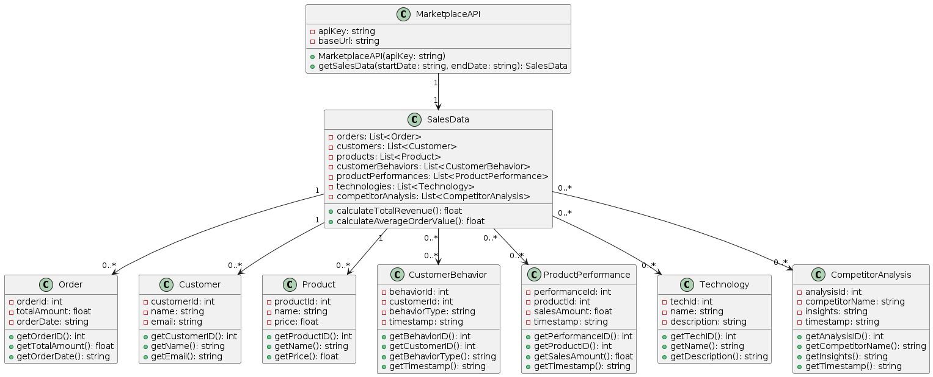

- Use Case Diagram

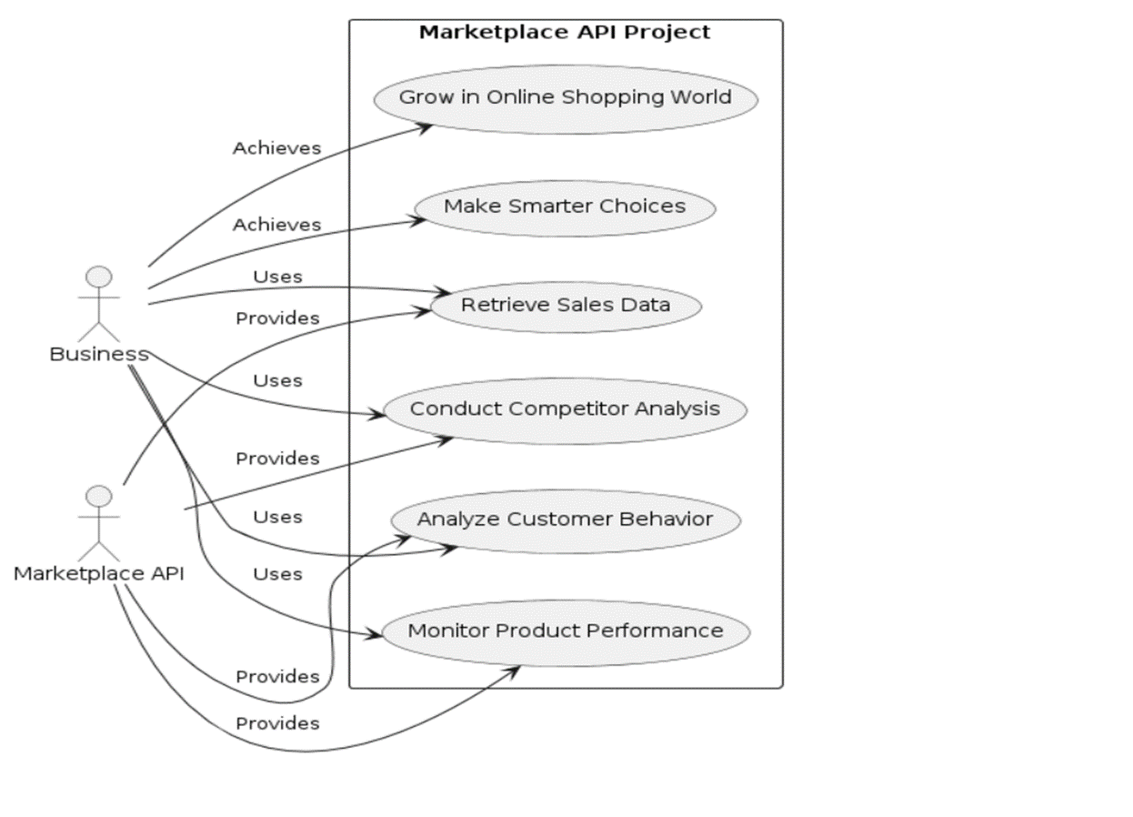
- Activity Diagram

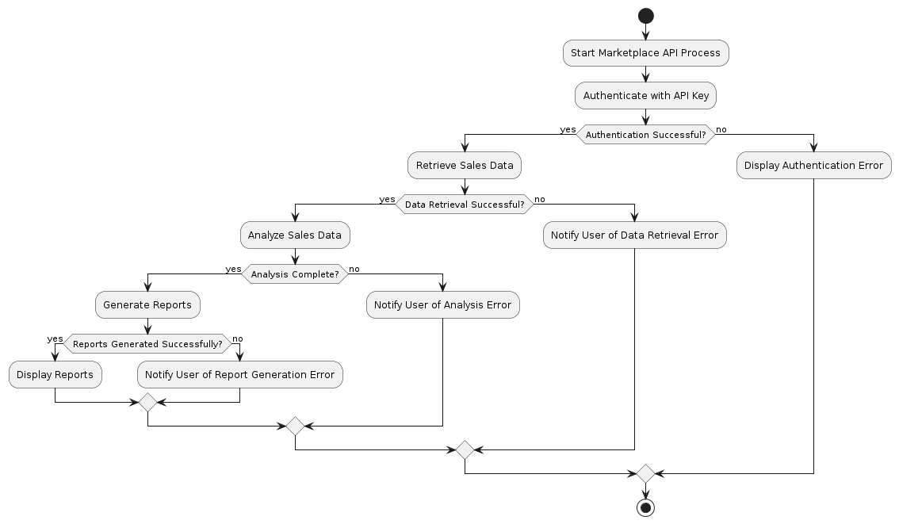
- Component Diagram

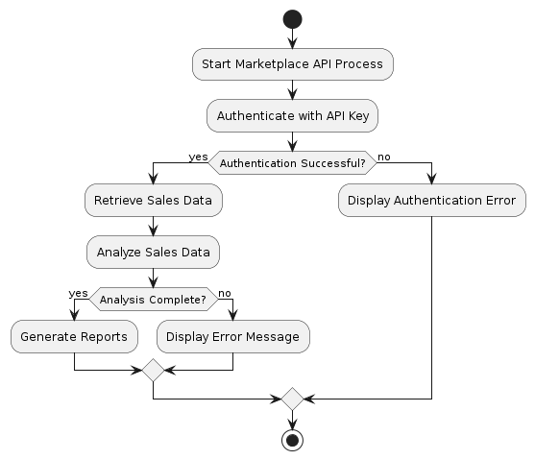
- Sequence Diagram

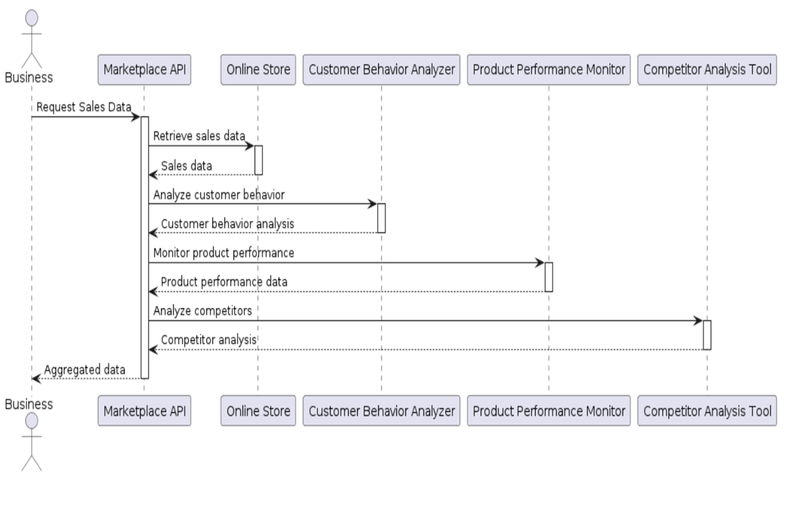

4. IMPLEMENTATION

4.1 SAMPLE CODE
import requests
class MarketplaceAPI:
def __init__(self, api_key):
self.api_key = api_key
self.base_url = "https://api.marketplace.com"
def get_sales_data(self, start_date, end_date):
headers = {"Authorization": f"Bearer {self.api_key}"}
params = {"start_date": start_date, "end_date": end_date}
response = requests.get(f"{self.base_url}/sales_data", headers=headers, params=params)
if response.status_code == 200:
return response.json()
else:
print("Error fetching sales data:", response.text)
return None
def analyze_sales_data(self, sales_data)
total_revenue = sum([order["total_price"] for order in sales_data])
average_order_value = total_revenue / len(sales_data)
return {"total_revenue": total_revenue, "average_order_value": average_order_value}
# Example usage:
if __name__ == "__main__":
api_key = "your_api_key_here"
marketplace_api = MarketplaceAPI(api_key)
# Fetch sales data for a specific date range
sales_data = marketplace_api.get_sales_data("2024-01-01", "2024-04-30")
if sales_data: # Analyze the sales data
analysis = marketplace_api.analyze_sales_data(sales_data)
print("Total Revenue:", analysis["total_revenue"])
print("Average Order Value:", analysis["average_order_value"])
  - OUTPUT SCREENS

- Start Page

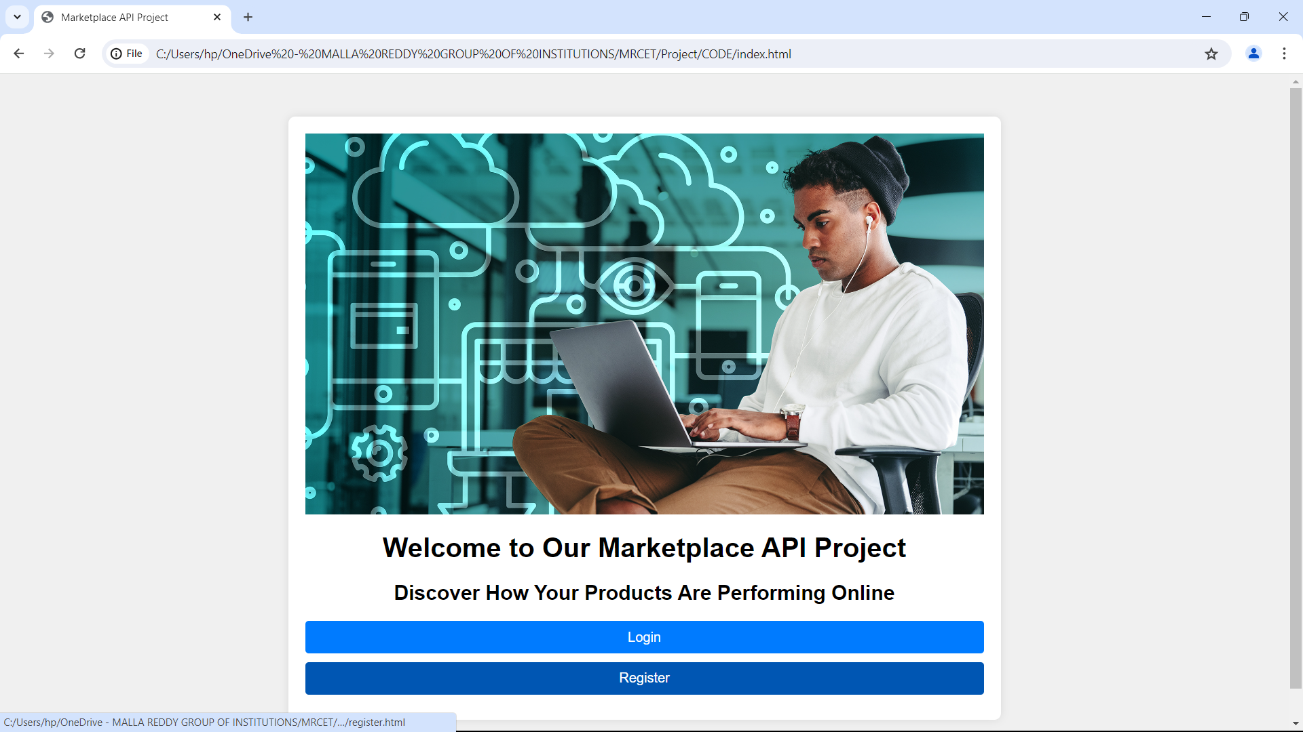

- Login and Registration

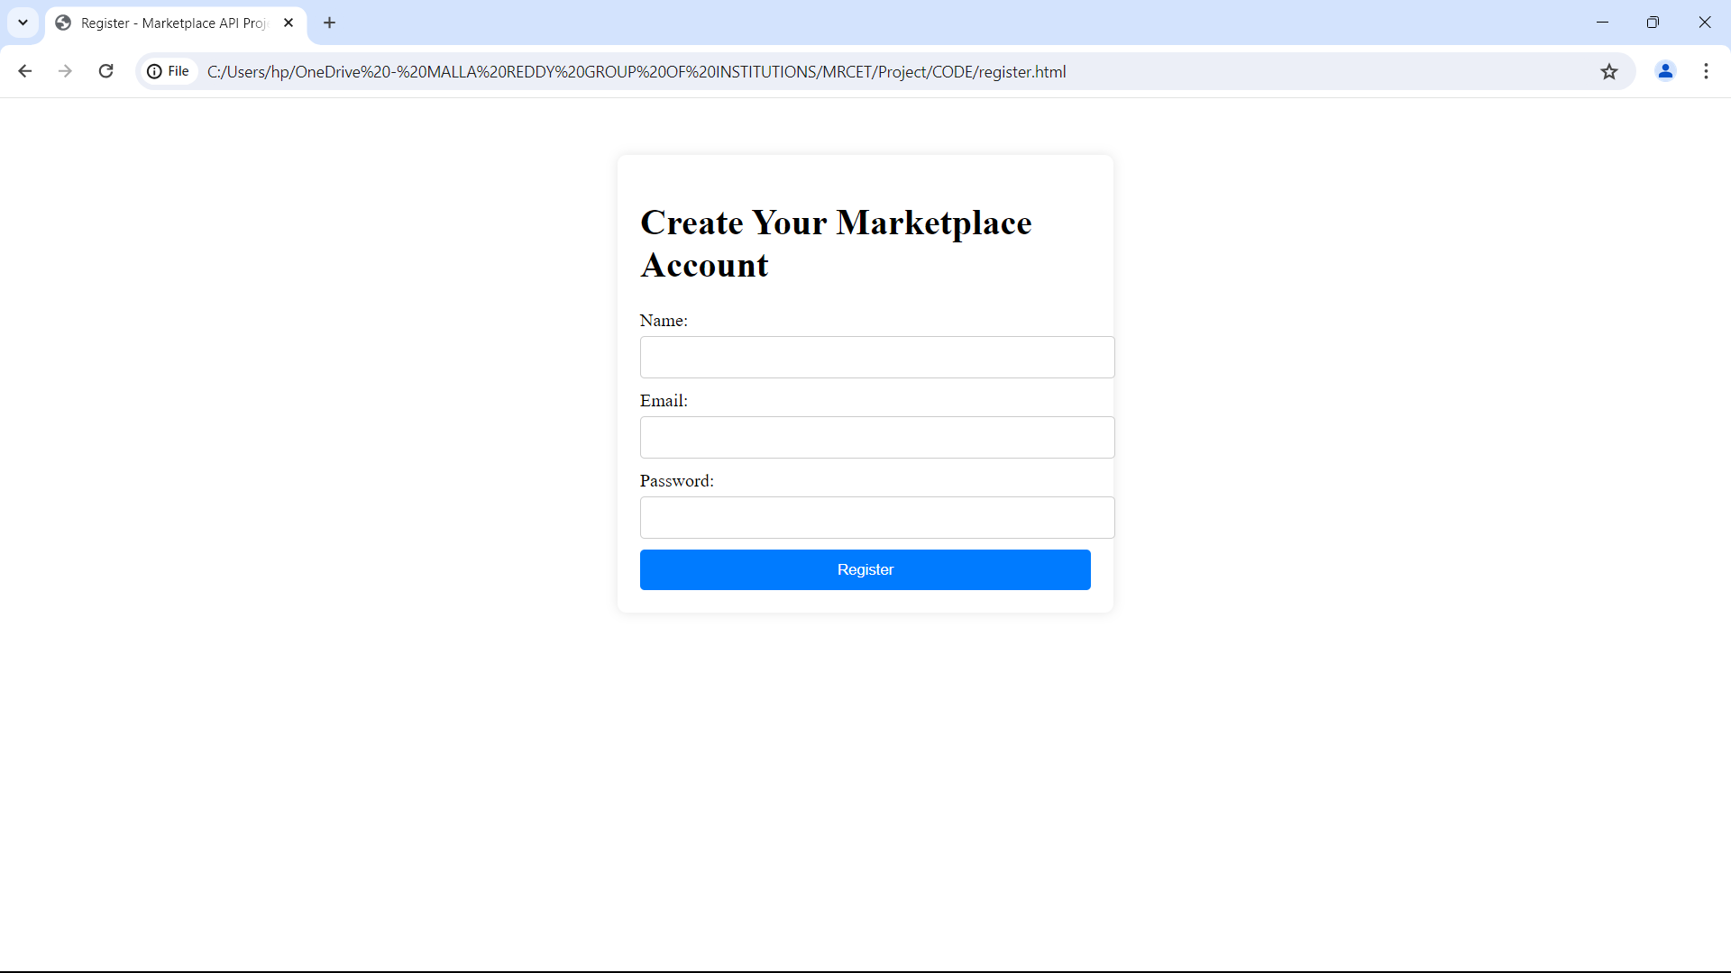
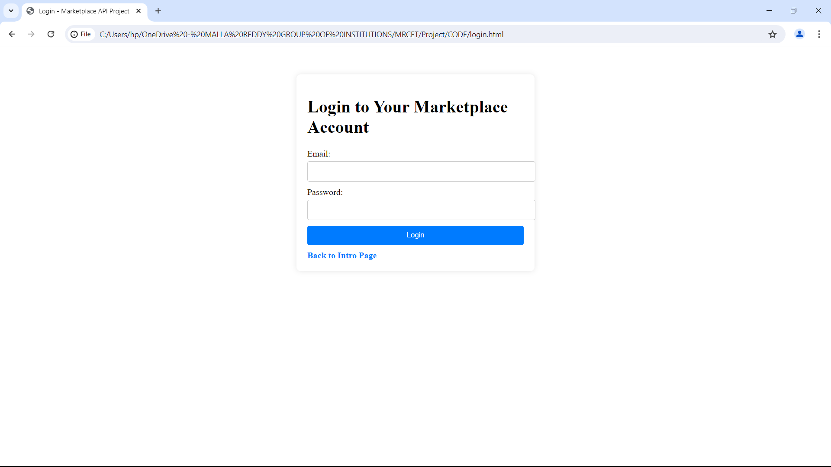
- Dashboard

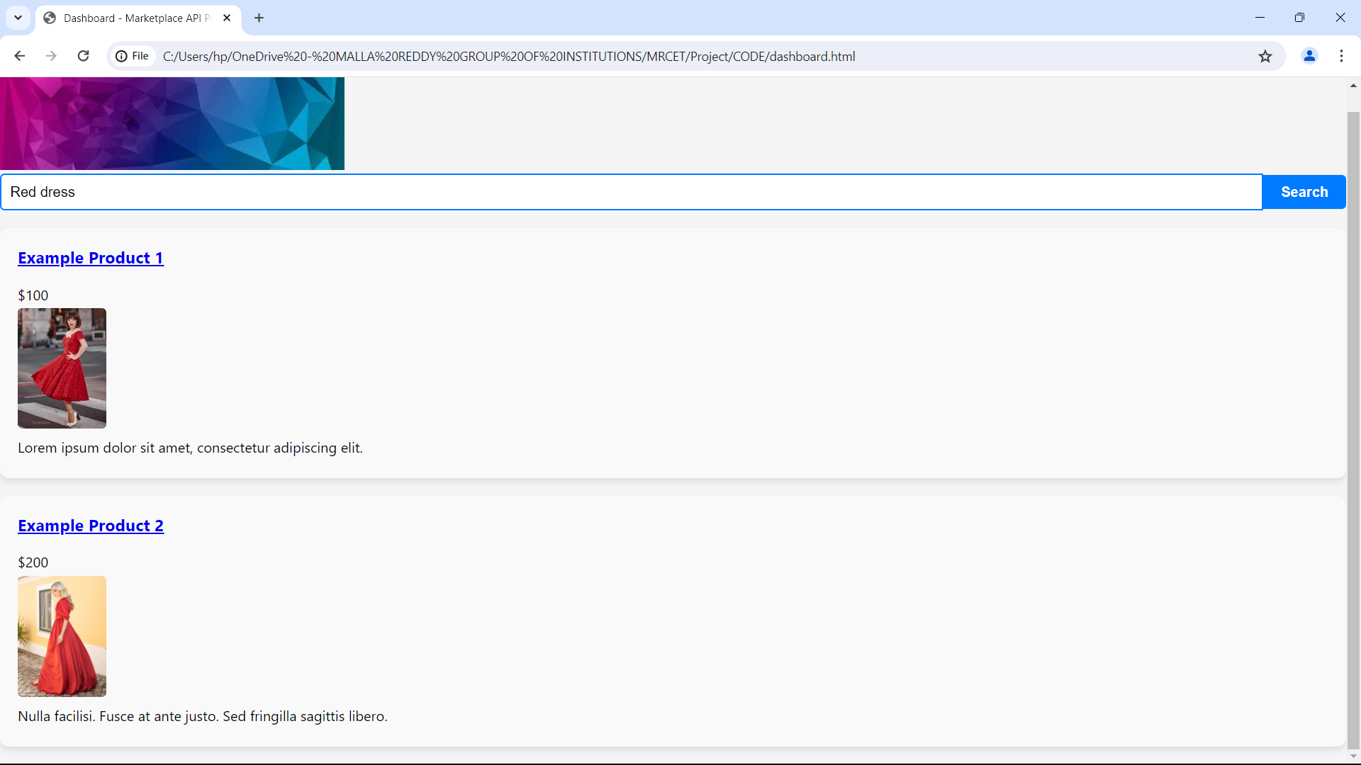
- Product Details

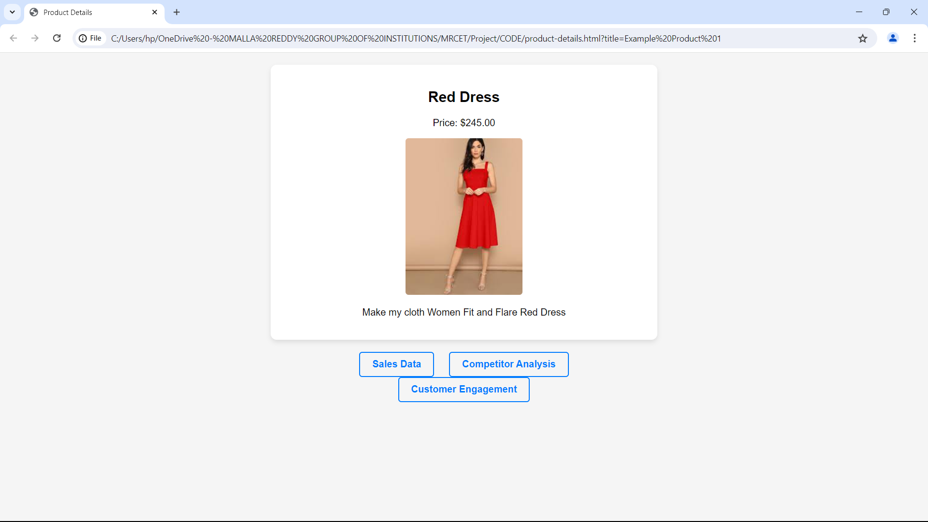

- Competitor Analysis

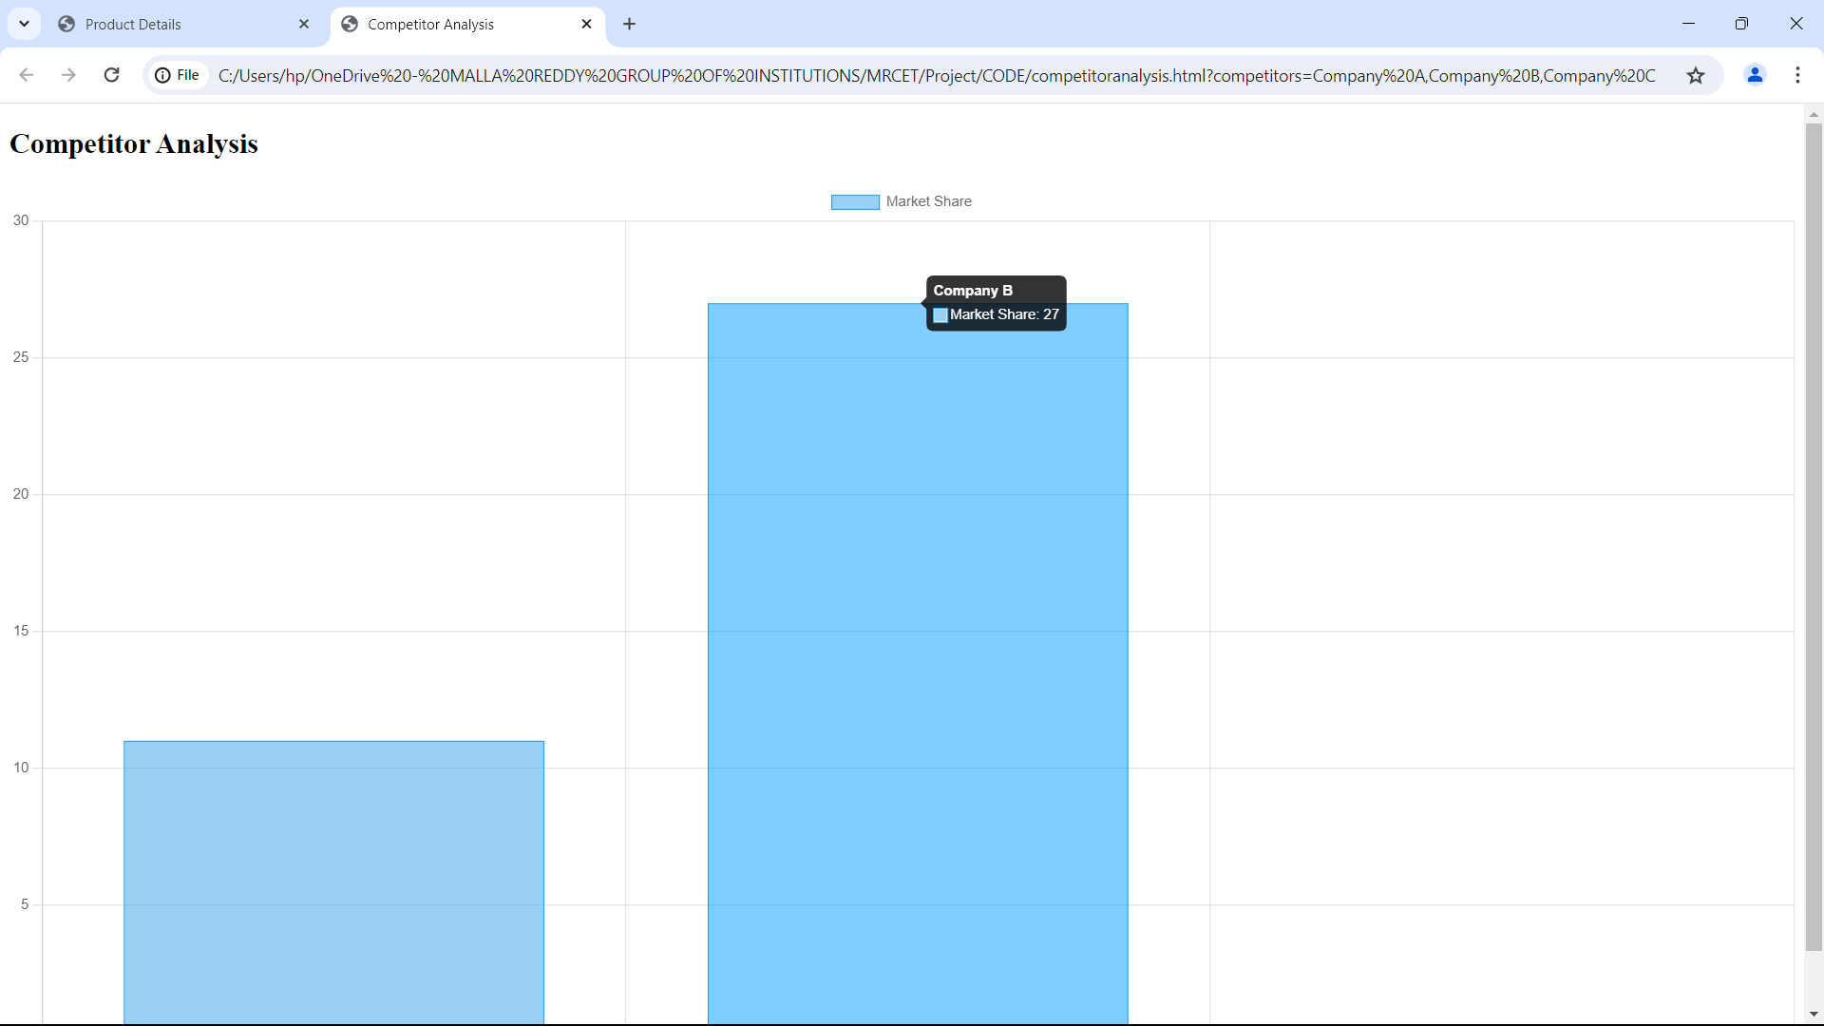
5.CONCLUSION
In summary, the Marketplace API project is changing how businesses use data from big online stores. Our platform is easy to use and effective, helping all kinds of businesses understand what's happening in the market, how customers act, and what competitors are doing. By using our platform, businesses can improve their products, make smarter plans, and stay ahead in online shopping.
Our goal is to help businesses do well in the fast-changing world of online shopping. With our Marketplace API project, businesses get insights that help them make smart decisions. Whether it's following product trends, watching competitors, or using advanced analytics, our platform gives businesses the tools they need to succeed online. Join us now and take your business to the next level in e-commerce.

